ESTIMATION OF BUSINESS EXPENSES

**NM Id: NN2023TMID31726**

1. **INTRODUCTION**

Overview

* + Estimating business expenses involves projecting the costs associated with running your business. Here’s an overview of the key steps:

Purpose

* + The purpose of the study is estimation of business expenses

1. **Problem Definition & Design Thinking**

Empathy Map

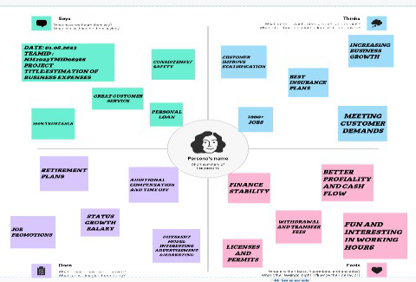

Ideation & Brainstorming Map

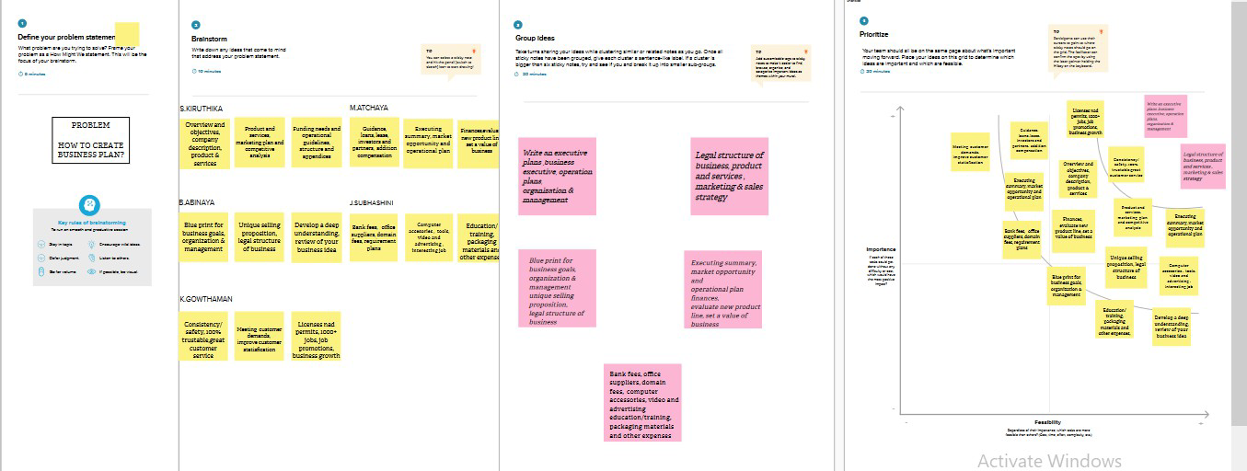

1. **RESULT**

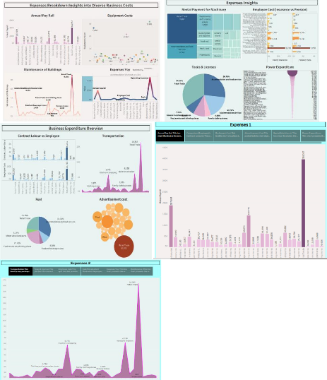

1. **ADVANTAGES & DISADVANTAGES**

**Advantages:**

* **Flexibility:** Estimating expenses allows for flexibility in budgeting. It's particularly useful for businesses with variable costs or those in their early stages when historical data may be limited.
* **Quick Decision-Making:** Estimations enable quick decision-making. Business leaders can make informed choices without waiting for detailed expense data.
* **Resource Allocation:** It helps allocate resources efficiently. By estimating expenses, a business can allocate funds to different areas, ensuring essential operations are funded.
* **Cost Reduction:** It can lead to cost reduction. Proactive estimation can help identify cost-saving opportunities and inefficiencies.

**Disadvantages:**

* **Inaccuracy:** Estimations are inherently less accurate than real data. Relying on estimates can lead to financial discrepancies and budget shortfalls.
* **Risk of Overestimation/Underestimation:** Estimating too high may result in unnecessary budget constraints, while estimating too low can lead to budget overruns.
* Limited Benchmarking Estimating doesn't provide historical data for benchmarking or learning from past experiences, making it harder to refine future estimates.
* **Auditing and Compliance:** In regulated industries, estimation may not suffice for audit and compliance purposes, requiring precise, documented-expenses.

1. **APPLICATIONS**
   * Annual PayRoll
   * Advertisement Cost
   * Contract Labour vs Employee
   * Employee(Insurance vs pension)
   * Equipment Costs
   * Expenses YoY
   * Fuel
   * Maintenance of Buildings
   * Power Expenditure
   * Rental Payment Machinery
   * Taxes & Licenses
   * Transportation
2. **CONCLUSION:**
   * In conclusion, effectively estimating business expenses is crucial for financial planning and sustainability. It involves a detailed analysis of various cost categories, such as operational, overhead, and variable expenses. By accurately forecasting and managing these costs, businesses can make informed decisions, allocate resources efficiently, and ultimately improve their profitability and long-term success.
3. **FUTURE SCOPE**

The estimation of business expenses is an integral part of financial planning, and its future scope is likely to evolve in several ways:

* + **Advanced Analytics and AI:** Businesses will increasingly rely on data analytics and AI-driven tools to predict and estimate expenses more accurately. This can include machine learning models that analyze historical data and external factors to make precise forecasts.
  + **Real-Time Tracking:** With the advancement of technology, real-time expense tracking will become more common. This allows businesses to adapt quickly to changes in expenses and make proactive decisions.
  + **Integration of Sustainability Costs:** As sustainability and environmental concerns grow, estimating and accounting for green initiatives and compliance expenses will be a significant aspect of business expense estimation.
  + **Globalization Challenges:** Businesses operating internationally will face new challenges in estimating expenses due to currency fluctuations, diverse tax regulations, and geopolitical events. Future expense estimation will need to account for these complexities.
  + **Automation and Robotics**: Businesses will increasingly employ automation and robotics, which will impact both fixed and variable expenses. Estimating expenses in this context will involve understanding the costs and benefits of automation.
  + **Cybersecurity Costs**: With the increasing importance of cybersecurity, businesses will need to budget for security measures and incident response in their expense estimates.
  + **Regulatory Changes:** As regulations change, especially in areas like healthcare or finance, businesses will need to adapt their expense estimation to ensure compliance.
  + **Predictive Cost Management:** Businesses may move beyond traditional budgeting to more dynamic predictive cost management, allowing for ongoing, flexible adjustment of expense estimates based on real-time data.
  + **Scenario Planning:** Enhanced scenario planning will be a crucial aspect of future expense estimation. Businesses will need to estimate expenses under various hypothetical conditions to make informed decisions.
  + **Environmental and Social Impact:** There's a growing emphasis on ESG (Environmental, Social, and Governance) factors. In the future, businesses will need to incorporate these considerations into their expense estimation, covering areas like employee well-being and community-engagement.